# Import Excel – Correct product list

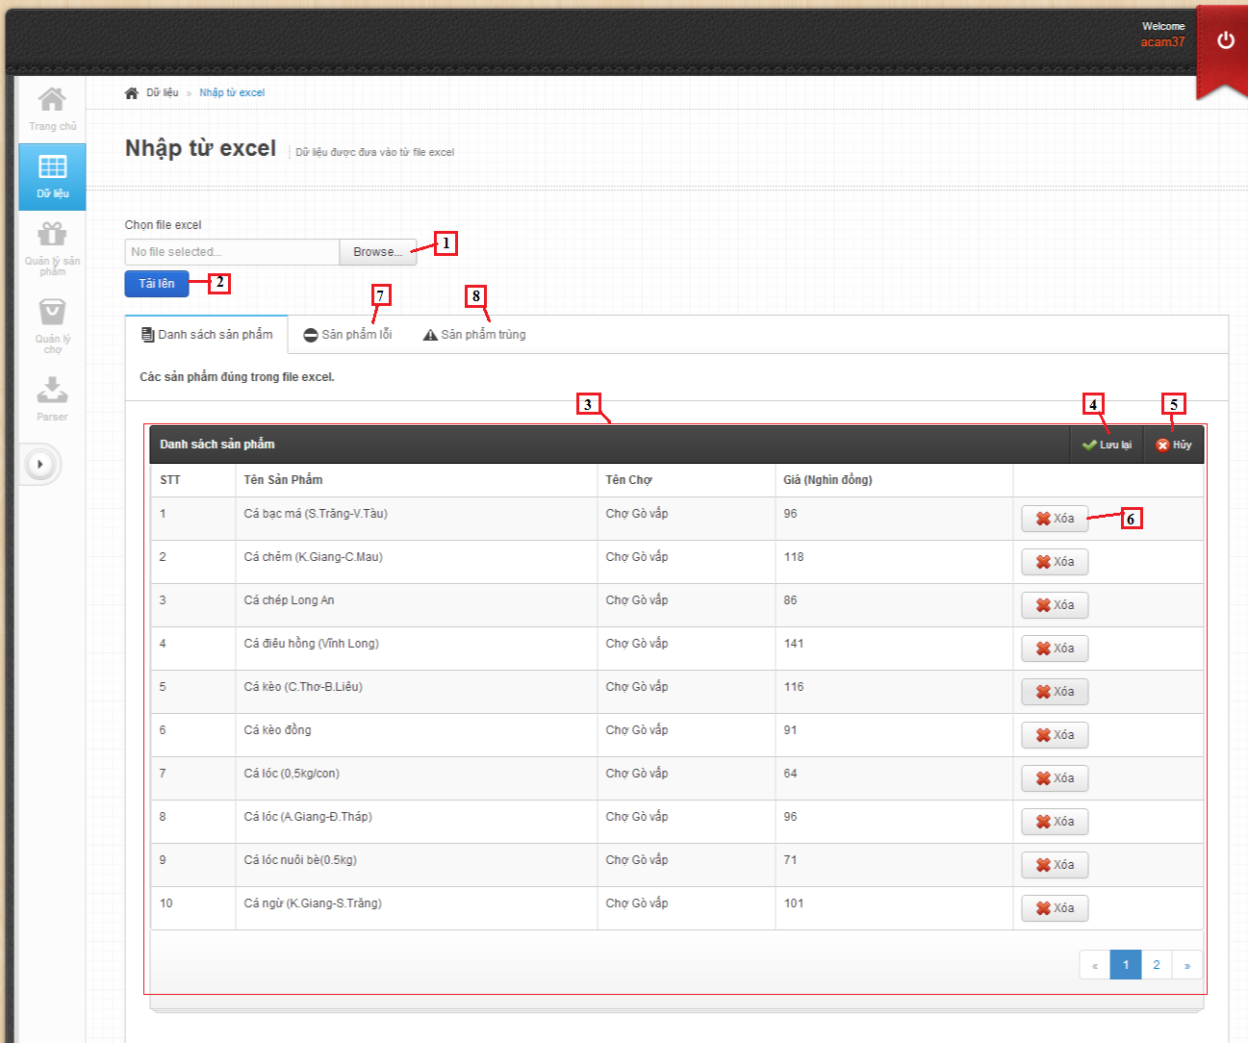

**Fields**

|  |  |  |  |  |  |  |  |
| --- | --- | --- | --- | --- | --- | --- | --- |
| **No** | **Field Name** | **Description** | **Read only** | **Mandatory** | **Control Type** | **Data Type** | **Length** |
| 3 | Product list | Show list product | No | No | Table list view | N/A | N/A |

**Button/ Hyperlink**

|  |  |  |  |  |
| --- | --- | --- | --- | --- |
| **No** | **Function** | **Description** | **Validation** | **Outcome** |
| 1 | Select excel file | Click to select excel file | N/A | N/A |
| 2 | Upload excel file | Get data in excel file | N/A | N/A |
| 4 | Save product | Click to save product into database | N/A | Show message result. |
| 5 | Cancel import | Click to cancel import product | N/A | N/A |
| 6 | Remove product | Click to remove product | N/A | N/A |
| 7 | Error product list | Click to transfer to error product list | N/A | Transfer to error product tab |
| 8 | Duplicate product list | Click to transfer to duplicate product list | N/A | Transfer to duplicate product tab |

**Product List includes**

|  |  |  |  |  |  |
| --- | --- | --- | --- | --- | --- |
| **Field Name** | **Description** | **Read only** | **Control Type** | **Data Type** | **Length** |
| Number row | Number of row | Yes | Textview | String | N/A |
| Product name | Show product name | Yes | Textview | String | N/A |
| Market name | Show market name | Yes | Textview | String | N/A |
| Price | Show product price | Yes | Textview | Integer | N/A |
| Action | Action for product | No | Button | N/A | N/A |

# Import Excel – Error product list

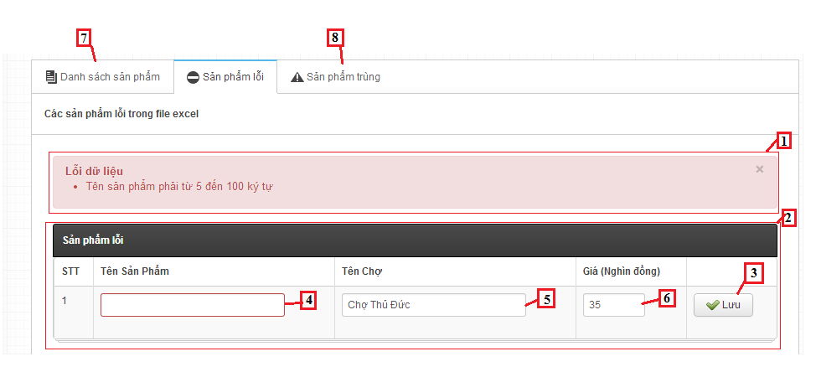

**Fields**

|  |  |  |  |  |  |  |  |
| --- | --- | --- | --- | --- | --- | --- | --- |
| **No** | **Field Name** | **Description** | **Read only** | **Mandatory** | **Control Type** | **Data Type** | **Length** |
| 1 | Message | Show error message | Yes | N/A | Textview | String | N/A |
| 2 | Error Product list | Show list product | No | No | Table list view | N/A | N/A |
| 4 | Product name | Fill name of product | No | Yes | Textbox | String | [6-100] |
| 5 | Market name | Fill name of market | No | Yes | Textbox | String | [6-100] |
| 6 | Price | Fill price of product | No | Yes | Textbox | String | [1-10000] |

**Button/ Hyperlink**

|  |  |  |  |  |
| --- | --- | --- | --- | --- |
| **No** | **Function** | **Description** | **Validation** | **Outcome** |
| 3 | Save product | Click to save product | N/A | N/A |
| 7 | Correct product list | Click to transfer to correct product list | N/A | Transfer to correct product tab |
| 8 | Duplicate product list | Click to transfer to duplicate product list | N/A | Transfer to duplicate product tab |

**Error Product List includes**

|  |  |  |  |  |  |
| --- | --- | --- | --- | --- | --- |
| **Field Name** | **Description** | **Read only** | **Control Type** | **Data Type** | **Length** |
| Number row | Number of row | Yes | Textview | String | N/A |
| Product name | Show product name | Yes | Textview | String | N/A |
| Market name | Show market name | Yes | Textview | String | N/A |
| Price | Show product price | Yes | Textview | Integer | N/A |
| Action | Action for product | No | Button | N/A | N/A |

# Import Excel – Duplicate product list

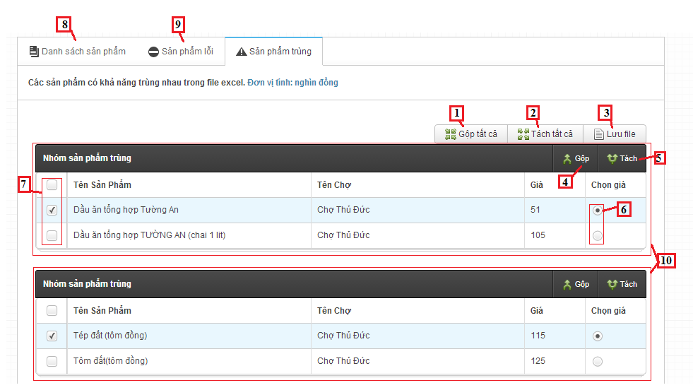

**Fields**

|  |  |  |  |  |  |  |  |
| --- | --- | --- | --- | --- | --- | --- | --- |
| **No** | **Field Name** | **Description** | **Read only** | **Mandatory** | **Control Type** | **Data Type** | **Length** |
| 10 | Duplicate product table | Show duplicate product | N/A | N/A | Table list view | N/A | N/A |

**Button/ Hyperlink**

|  |  |  |  |  |
| --- | --- | --- | --- | --- |
| **No** | **Function** | **Description** | **Validation** | **Outcome** |
| 1 | Join all product | Click to join products in each table | N/A | N/A |
| 2 | Divide all product | Click to divide product in each table | N/A | N/A |
| 3 | Save log file | Click to save duplicate product to text file | N/A | Show message result |
| 4 | Join product | Click to join products in current table | N/A | N/A |
| 5 | Divide product | Click to divide product in current table | N/A | N/A |
| 6 | Price | Select price of product | N/A | N/A |
| 7 | Checkbox product | Click to select product | N/A | N/A |
| 8 | Correct product list | Click to transfer to correct product list | N/A | Transfer to correct product tab |
| 9 | Duplicate product list | Click to transfer to duplicate product list | N/A | Transfer to duplicate product tab |

**Duplicate Product List includes**

|  |  |  |  |  |  |
| --- | --- | --- | --- | --- | --- |
| **Field Name** | **Description** | **Read only** | **Control Type** | **Data Type** | **Length** |
| Checkbox | Checkbox of product | N/A | Checkbox | Checkbox | N/A |
| Product name | Show product name | Yes | Textview | String | N/A |
| Market name | Show market name | Yes | Textview | String | N/A |
| Price | Show product price | Yes | Textview | Integer | N/A |
| Select price | Action for product | N/A | Radio | radio | N/A |

# Manage Product – View Product

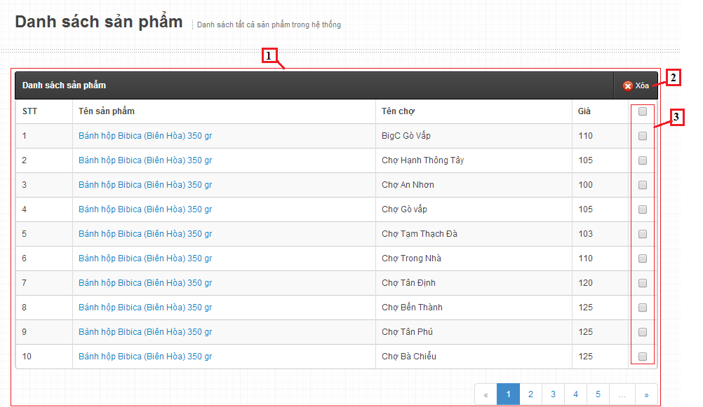

**Fields**

|  |  |  |  |  |  |  |  |
| --- | --- | --- | --- | --- | --- | --- | --- |
| **No** | **Field Name** | **Description** | **Read only** | **Mandatory** | **Control Type** | **Data Type** | **Length** |
| 1 | product table | Show product | N/A | N/A | Table list view | N/A | N/A |

**Button/ Hyperlink**

|  |  |  |  |  |
| --- | --- | --- | --- | --- |
| **No** | **Function** | **Description** | **Validation** | **Outcome** |
| 2 | Delete Product | Click to delete product | N/A | N/A |
| 3 | Checkbox product | Click to select product | N/A | N/A |

**Product List includes**

|  |  |  |  |  |  |
| --- | --- | --- | --- | --- | --- |
| **Field Name** | **Description** | **Read only** | **Control Type** | **Data Type** | **Length** |
| Number row | Number of row | Yes | Textview | String | N/A |
| Product name | Show product name | Yes | Textview | String | N/A |
| Market name | Show market name | Yes | Textview | String | N/A |
| Price | Show product price | Yes | Textview | Integer | N/A |
| Checkbox | Checkbox of product | N/A | Checkbox | Checkbox | N/A |

# Manage Product – Create Product

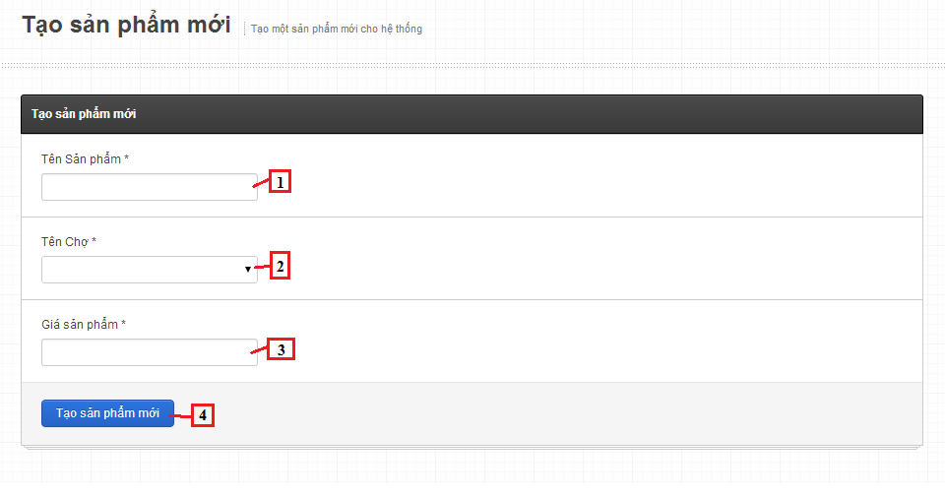

**Fields**

|  |  |  |  |  |  |  |  |
| --- | --- | --- | --- | --- | --- | --- | --- |
| **No** | **Field Name** | **Description** | **Read only** | **Mandatory** | **Control Type** | **Data Type** | **Length** |
| 1 | product name | Fill name of product | No | Yes | Textbox | String | [6-100] |
| 2 | Market name | Fill name of market | No | Yes | Dropdown list | String | N/A |
| 3 | Price | Fill price of product | No | Yes | Textbox | Integer | [1-10000] |

**Button/ Hyperlink**

|  |  |  |  |  |
| --- | --- | --- | --- | --- |
| **No** | **Function** | **Description** | **Validation** | **Outcome** |
| 4 | Save product | Click to save product into database | Yes | Transfer to manage product pages. |